Denoising Fundus Image Based on

Sparse Representation and Redundant Dictionary

YangXuan and LiAo

【**Abstract**】

The processing of fundus image has played an increasingly important role in the medical imaging recent years. Because there are many weak capillary vessels in the fundus image and most of them are similar to the strength of the background noise in the image, It makes the denoising background noise task become much more difficult than the other types of image. How can effectively denoise the background noise in the fundus image is significant in the area of medical and computer science. In this paper, firstly, we adopt the Frangi vessel enhancement algorithm to enhance the fundus image, which was not directly used to the whole image, but to pre-process the fundus image local adaptively, especially aiming to distinguish the patches of wide vessel and the small weak capillary vessel by the variance. The purpose of doing this work is to minimize the number of the noise after pre-processing in the fundus image. Then using the manual fundus image with some methods to get the initial dictionary. Lastly, use and add some improvements to the basic principle of the K-SVD learned dictionary and OMP sparse representation, making it more effectively to reconstruct the fundus images. Mainly section of the improvements is to set a directional filter to detect the linear structure in the fundus image. The linear structures can discriminate the weak small capillary vessel and the noise in the fundus image. Find a suitable threshold to distinguish the wide vessel and the weak small vessel through the several experiments, giving a weighting to the weak vessel for the sparse representation.

**Keywords**：K-SVD; directional filter; learned dictionary; sparse representation; image denoising

1. **INTRODUCTION**
2. ***The Importance of Fundus Image***

According to the exist researches, the fundus image is such an important mean for medical auxiliary diagnosis and treatment, besides it has become one of the practical applications of computer technology in medical area [1], [2]. It is such a direct, valid and standardized mean for diagnosis. Statistics show that many ocular fundus diseases and some systemic diseases can be directly or indirectly judged from diagnosing the fundus images. Because many ocular fundus diseases and systemic diseases can lead the vessels to display abnormally, we can make fully use of the fundus images for treatment. For example, diabetic retinopathy is one of the complications of diabetes mellitus affecting the retina and the choroid, in this condition, a network of small blood vessels, called choroid neovascularization (CNV), arises in the choroid [3]. The physicians now summarize the characteristic of these vessels in fundus images and try to treat this dangerous disorder by applying optical energy to photocoagulate the neovascularization. Moreover, for the sake of better concluding these vessels’ abnormal characteristic, we are supposed to use a fundus camera for capturing the fundus images. These fundus images are to be accurately segmented to extract the sensitive objects in the retina such as the blood vessels. The original fundus image’s example is shown in the Fig.1.

So detection of blood vessels in retinal fundus image is the preliminary step to diagnose several diseases. However, the fundus images are easy to be disturbed by various factors (obtain, store and process etc.). A series of operations will let the fundus images be full of noises, seriously affecting the fundus images’ definition. The noises, which are some useless signals for interfering with useful signals. They always generate by some reasons at random, with irregular size and distribution. So for the sake of helping doctor better diagnosis, denoise the fundus image is particularly important and the important step is to detect the blood vessels in order to distinguish the vessels and the noises.

1. ***Exist Research on Detecting the vessels in Fundus Image***

Nowadays, there exist several methods to automatically detect blood vessels from retinal image with the aid of different computational methods. Lastly used methods are：1) Phase congruency：is a dimensionless quantity that is invariant to changes in image brightness or contrast; It is a high speed detection of retinal blood vessels using phase congruency and a bank of log-Gabor filters, been proposed by Amin and Yan [4]. 2) Using planes and centerline detection：Fraz et al. have proposed a unique combination of vessel centerlines detection and morphological bit plane slicing to extract the blood vessel tree from the retinal fundus images. This method has got a great success to detect the vessels than before, but still has a space to improve [5]. 3) Global thresholding techniques：There are some different vessel detection techniques based on global thresholding using phase congruency and contrast limited adaptive histogram equalization(CLAHE) for the retinal fundus images. However, this method cannot distinguish weak vessels and strong noise well [6].Although there are many other ideas to denoise the fundus images, they still need to improve themselves.

In this paper, we propose a new approach which was not published before, that is -----Dictionary denoising. Use training method to obtain a redundant dictionary. Then use the sparse representation matric to reconstruct the fundus images. Although this method is much more complex and the program execution time is longer than the other methods, it can effectively denoise and get a more clear fundus images as well.

1. ***Contributions of our work***

We have already mentioned that the imaging agents or other objective physical conditions can influence the fundus images so that there are many background noises in them. Besides, after observing the Fig.2 (wide vessel in blue frame and weak vessel in green frame), we can obviously see that the strength of the weak vessels differ a lot from the strong vessels, but they are similar to the strong noises. So, the great number of strong noises would make exist denoise methods’ result perform not pretty well. In this paper, we have two main contributions, aiming at improving the denoise results.

The first one is that we use the sparse representation and redundant dictionary to denoise the fundus images. It is a novel idea to apply the sparse representation method to the fundus images, because there are not relevant published essay or research that is about this idea. However, limited to the strength of the weak vessels (pretty weak and similar to the noise), It is difficult for the redundant dictionary to reconstruct the linear structure of the weak vessels from the strong noise. The denoise results cannot reach the purpose of diagnosing the diseases as well.

Therefore, we propose the second idea, which is that select a suitable directional filter to highlight the weak vessels linear structure in the fundus image first then to denoise the image. In other words, we use some methods to divide the fundus image into small patches, and use different methods to the weak vessels patches and the wide vessels patches. More will be said in the following sections.

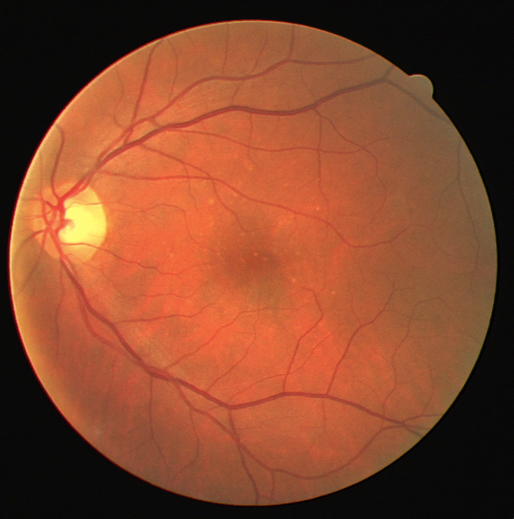

Fig.1 the original fundus image

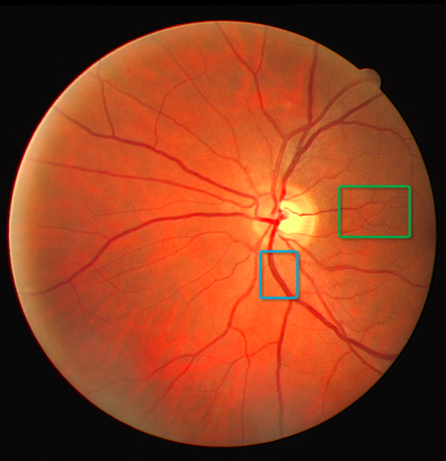

Fig.2 wide vessel and weak vessel

1. **ALGORITHM MODEL**
2. ***Existing Problems in Frangi Filter***

In this paper, we choose Frangi filter vessel enhancement algorithm to sharpen the original fundus images. This is such an effective approach to enhance the weak vessels to the fundus images. But there are large differences in the strength of wide vessels and weak vessels (Obviously could see in the Fig.2), if use the same Frangi parameters to these different strength of the vessels, it will generate many background noises after the enhancement. So, to the weak vessels, the Frangi parameters should be adjusted accordingly, keeping the background noises of the fundus image still in the acceptable range. However, it requires using block-processing method to solve this problem. That is, the wide vessels use larger Frangi parameters and the weak vessels use smaller Frangi parameters. Therefore, the image enhancement problem is transformed into cutting the fundus images into multiple overlapping pieces, and the current work is that how to distinguish these patches are the wide vessel block or the weak vessel block. We will describe the improvement methods in section C- (a).

1. ***Sparse Model and Learned Dictionary for Image Patches***
2. ***Sparse Model Principles***

In this paper, we will use the redundant dictionary and the sparse representation to denoise and reconstruct the fundus image. We consider the image patches of size $\sqrt{n}×\sqrt{n}$ pixels, ordered lexicographically as column vectors $x∈R^{n}$. Given a Dictionary $D∈R^{n×k}$ (with k>n, implying that the dictionary is redundant). So, the image patch x could be represented sparsely over the redundant dictionary D. As follows

$x≈Dα$ (1)

where $α$ stands for the sparse coefficient representation matrix. In Fig.3, It is shown the sparse model that is described in (1). We can see that the problem is transformed into obtain a suitable dictionary D and a minimum sparse coefficient representation matrix $α$. In this paper, we adopt two methods to denoise the fundus image. 1) Firstly, select a suitable and fixed dictionary. Then use the sparse decomposition algorithm (we use OMP algorithm in this paper) to obtain a minimum count of the nonzero entries in $α$. 2) Also through select a suitable dictionary D (the initial D is the same as in 1), but not fixed at all), but then iteratively use the dictionary update algorithm(we use K-SVD algorithm in this paper) and use the sparse decomposition algorithm，respectively updating the D and obtaining the $α$.

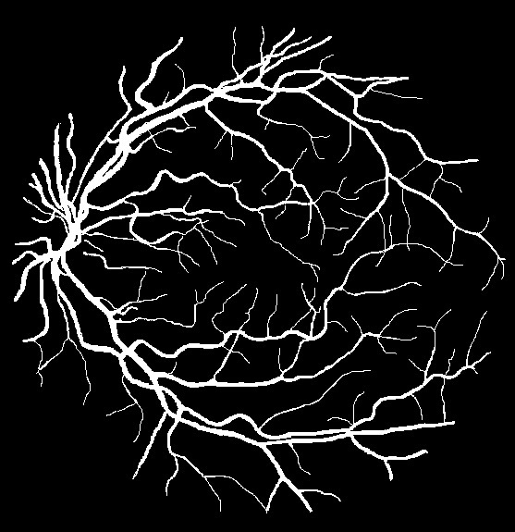

Fig.4. Manual segmentation fundus image

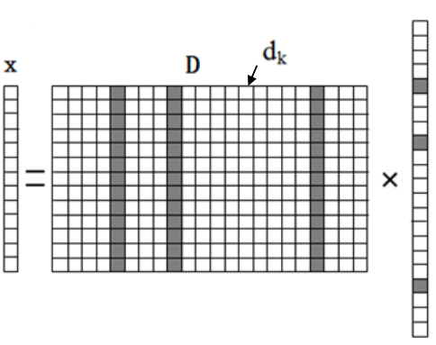

Fig.3. The sparse model

In the denoising process, the first step is to use the initial dictionary D and the sparse decomposition algorithm to obtain the sparse coefficient matrix. The solution of

$$α =arg\min_{α}{||α{||}_{0}} s.t. Dα≈x$$

(2)

is indeed very sparse, that is, $||α{||}_{0}≪n$. The notation $||α{||}_{0}$ represents the count of the nonzero entries in $α$. The idea here is that every signal instance from the family we consider can stand for as a linear combination of few columns from the redundant dictionary D. However, the model above can be made more simple by replacing the rough constraint $Dα≈x$ with a clear requirement to allow a bounded representation error, that is, $||x-Dα{||}_{2}^{2}≤ε$. Also, we need to define the sparsity, adding a requirement of the form $||α||_{0}≤L≪n$, that states that the sparse representation uses no more than L atoms from the dictionary for every image patch. We define the triplet $(ε，L，D)$,

$$α=arg\min_{α}{||α{||}_{0}} s.t. ||Dα-y{||}_{2}^{2}≤T$$

(3)

where y stands for a noisy image, contaminated by an additive zero-mean white Gaussian noise with standard deviation $σ$. Tis dictated by $ε$ and $σ$.The reason that the above model can denoise the background noises in the image is that, under the premise of the appropriate dictionary, image will have its own sparse representation. The (3) can reconstruct the image without noise by estimating the sparse representation of the original clean image. Notice that the above optimization task can be changed to be

$$α=arg\min_{α}{||Dα-}y{||}_{2}^{2}+μ||α{||}_{0}$$

(4)

so that the constraint becomes a penalty. For a proper choice of $μ$, the two problems are equivalent.

1. ***Learned Dictionary Principles***

The K-SVD algorithm is a popular dictionary training algorithm at present. It is updated column by column. So, compared to the MOD algorithm in the dictionary update field, the K-SVD algorithm has a relatively high efficiency. The brief introduction of the K-SVD algorithm as follows:

The key of the K-SVD algorithm is to train a dictionary that can effectively represent the signal samples. The solution as follows

$$\min_{D,X}{||X-DA{||}_{2}^{2}} s.t. ∀i, ||α_{i}{||}_{0}≤L$$

(5)

where $X=\{x_{i}\}_{i=1}^{N}$ stands for a noisy image, making up by some small patches, $D∈R^{n×k}$（k>n）， $A=\{α_{i}\}_{i=1}^{n}$, i=1,2,…,n. $α_{i}$ stands for each patches of the $x_{i}$’s sparse representation coefficient vector. L represents the upper limit of the number of non-zero elements. So, transform (5) to (6)

$$\min_{α_{i}}{||x_{i}}-Dα_{i}{||}_{2}^{2} s.t. ||α_{i}{||}_{0}≤L$$

(6)

where we can use OMP algorithm to obtain $α_{i}$. This phase is called sparse decomposition. Then use the following

$$||X-DA{||}_{2}^{2}=||X-\sum_{j=1}^{k}{d_{j}α_{j}{||}_{2}^{2}}=||(X-\sum_{j≠k}{d_{j}α_{j}})-d_{k}α_{k}||=||E_{k}-d_{k}α_{k}{||}_{2}^{2}$$

(7)

In this phase, $E_{k}$ stands for a residual value that excludes $d_{k}$ ($E_{k}= X-\sum_{j≠k}{d_{j}α_{j}}$), K-SVD uses this value to update the dictionary’s atoms. Because K-SVD can guarantee this value decrease by the increase number of the iteration, when the sparse residual error is small enough (reach to the limit value we set), we could attain a minimum dictionary with the smallest residual value. Besides, the K-SVD algorithm will continue to repeat with sparse coding parse and dictionary update parse, until the residual value reaches the limit value.

1. ***Problems***

However, the traditional K-SVD and OMP algorithm is not aimed at processing the fundus images. So, the denoising result is not really well. According to several experiments, we find that the initial dictionary’s atom (DCT dictionary) in traditional K-SVD algorithm cannot describe the vessels’ linear structure in detail, especially to the small weak vessels. It is difficult to reconstruct the fundus images. Besides, the weak vessels’ residual value is so small that it seriously affects the weak vessels’ reconstruction result. In other words, if we just take a unified sparse decomposition of the whole fundus image, that is, if the wide vessels and weak vessels in the fundus image take the same degree of decomposition, it will definitely lead to a poor reconstruction result. Thereby we will improve the traditional methods in the following section C.

1. ***Improvements for the Algorithm***
2. ***Block processing***

Because the strength of wide vessels and weak vessels differ too much, for the sake of solving this problem, we adopt the block processing in this paper. The problem describe in section A can be solved by the sub blocks’ variance. According to the characteristic of the variance of the sub block, the wide vessel blocks’ variance is large and the weak vessel blocks’ variance is small. Through the multiple sets of the experimental tests, with the output of the block’s variance, we ultimately determine to set variance=50 as the critical value to distinguish the wide and the weak vessels. That is when variance $≥$ 50, the sub block has the wide vessels, on the contrary, when variance < 50, the sub block has the weak vessels (in this paper, the sub block is an 32 $×$ 32 pixel image). In Fig.5, we present two images, which are the original fundus images after the Frangi filter enhancement. Using uniform Frangi parameters for the entire image is described on the left side of Fig.5. Using different Frangi parameters to the wide vessel blocks and the weak vessel blocks is shown on the right side of the Fig.5. The vessels are described more detail in Fig.6.

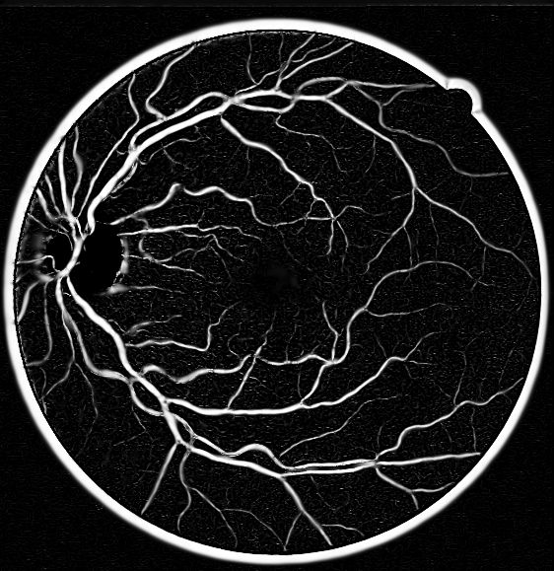 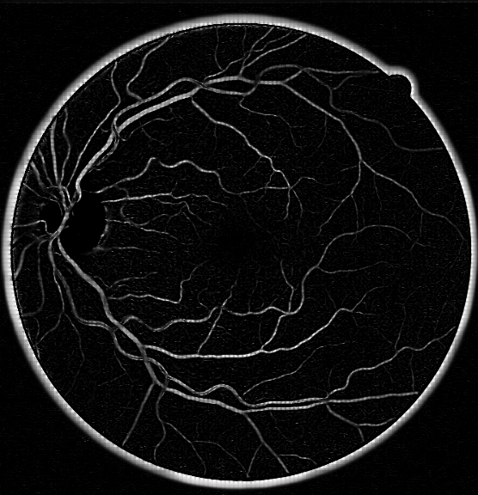

Fig.5. Left: uniform Frangi parameters Right: Local adaptive Frangi parameters

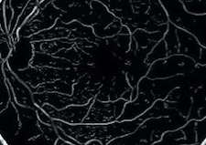 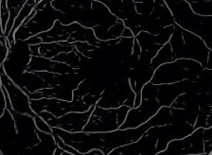

Fig.6. Left: uniform enhancement Right: block-processing enhancement

In detail

It is obviously that the right side of the image’s background noises has been greatly improved than the left side of the image in Fig.5. However, compared to Fig.4, we can obviously see that the weak vessels’ linear structure still display insufficiently. So in the following part, we will describe the improvement in the K-SVD and OMP algorithm to weight the weak vessel’s linear structure.

1. ***Improvement in Selecting Initial Dictionary***

As mentioned above, we find that the initial dictionary, which is DCT dictionary, lacks atoms that can fully expressed vessels. Besides, in K-SVD algorithm, the final optimization dictionary is based on the initial dictionary. So we need to improve the initial dictionary. The improved atoms can more effectively describe the vessels’ linear structure. The improvement as follow:

Firstly, select a suitable size block from a manual segmentation fundus image , like showed in Fig.4 (in our experiment, the original fundus image’s size is 565×584 and the block’s size is 32×32), the block need to contain the characteristic of the original image, (wide vessel and weak vessel etc. for example in Fig.7). Then, using the sliding windows(set 8×8) to obtain some overlap smaller patches, Finally, Because if the two patches’ inner product is smaller, it stands for these two images’ similarity is smaller. We can use this feature, choosing K smallest similarity of patches as the dictionary atoms (K=512 in our experiment). The difference between the initial dictionary generated by the method above and the DCT dictionary is shown in Fig.8. But the size of dictionary K ----- an option we do not explore in this work.

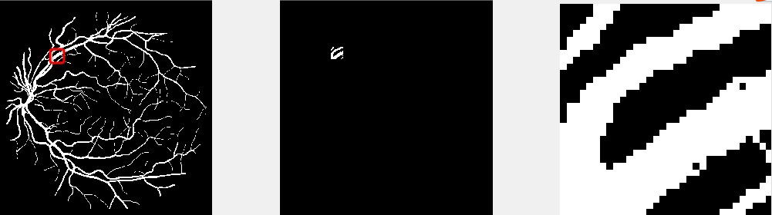

Manual segmentation Selected feature block Enlarged block

Fundus image

Fig.7. Select a feature block from a manual segmentation fundus image

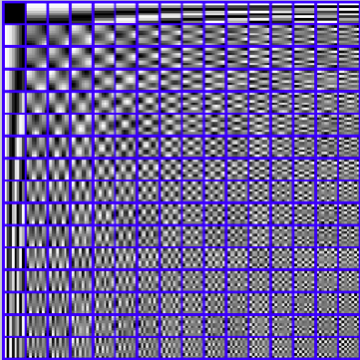 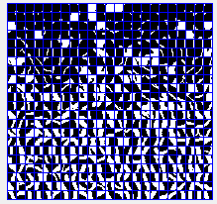

DCT dictionary trained dictionary from segmentation image

Fig.8. Difference between DCT dictionary and dictionary our method trained

1. ***Improvement in Sparse Coding Algorithm（directional filter）***

Although the expression of the vascular structure by the improved dictionary atoms has been improved a lot. The weak vessels’ reconstruction is not really well. According to the several experiments, we find the reason is that the weak vessels’ weight is similar to the strong noise in the background. So, we thought that maybe we can weight the weak vessels’ linear structure first, and then to denoise the background noises. In this paper, we choose a directional filter to judge the weak vessels linear structure. The specific method is as follow:

1. Set a directional filter:

The filter has 8 directions. The 8 angles are $θ_{1}$ =0， $θ_{2}=\frac{π}{8}$， $θ_{3}=\frac{π}{4}$， $θ_{4}=\frac{3π}{8}$, $θ_{5}=\frac{π}{2}$, $θ_{6}=\frac{5π}{8}$, $θ_{7}=\frac{3π}{4}$, $θ_{8}=\frac{7π}{8}$ respectively.

1. Judge the vessel type:
2. After Frangi filter enhancing the patches, we put the patches pass the directional filter. Calculate the energy on the $θ_{i}$ bands $posE_{θ_{i}}$ and the other bands’ energy $negE_{θ_{i}}$. The solution is,

$${posE}_{θ_{i}}=\sum_{x=1}^{N}{\sum_{y=1}^{N}{|f_{θ_{i}}(x,y)|^{2}}}$$

(8)

$$negE_{θ_{i}}=\sum_{x^{'}=1}^{N}{\sum_{y^{'}=1}^{N}{|f_{θ_{i}}(x^{'},y^{'})|^{2}}}$$

where i=1,2,…,8 and N is the size of the patch. The notation $θ_{i}$ stands for the 8 directions in the directional filter. The notation $f_{θ_{i}}(x, y)$ represents the pixel value in $θ_{i}$ bands, corresponding to the point (x, y) in the image. The notation $f_{θ_{i}}(x^{'},y^{'})$ represents the pixel value in other directional bands, that is except $θ_{i}$ bands, corresponding to the point (x, y) in the image.

1. Calculate the total energy value of the patches in the i direction band. The definition is

$$allNorm(i)= posE_{θ_{i}}- negE_{θ_{i}}$$

(9)

The total energy value of each direction is obtained by turn and it can be used to determine the direction of the vessels in the fundus image so as to analyze the direction of the linear structure. The direction is the direction of the vessel in the direction of the maximum total energy value.

$$E_{max}=\max_{i=1,2,…,8}{allNorm(i)}$$

(10)

1. According to the several experiments, find a reasonable maximum threshold for judging what the patch contains, wide vessels or weak vessels. If the patch contains weak vessels, we need to weight the vessels linear structure, for the sake of distinguishing the weak vessels and the strong noises in the image.

$\left\{\begin{aligned}E_{max}≥threshold is weak vessel \\ E_{max}<threshold is wide vessel\end{aligned}\right.$

(11)

1. In the subsequent sparse decomposition stage，we adopt different decomposition parameters to the wide vessel patch and the weak vessel patch so that there are more weak vessels that can reconstruct after denoise.
2. **RESULT**
3. ***Compare the Denoising Result***

In this section, we demonstrate the results achieved by applying the above improve methods on several test images, and with several dictionaries. In Fig.9, we summarizes these denoising results for the DCT dictionary, the globally trained dictionary, the adaptive dictionary, the improved globally trained dictionary, and the improved adaptive dictionary. In all this set of experiments, the dictionaries used were of size 64×512, designed to handle image patches of size 8×8 pixels (n=64, k=512). Every result reported is an average over 10 experiments, having different realization of the noise. Besides, in all 5 type of dictionary experiments, the denoising process included a sparse decomposition of each patch of size 8×8 pixels from the noisy image. Using the OMP, atoms were accumulated till the average error passed the threshold.

The redundant DCT dictionary is described on the left side of Fig.8, each of its atoms shown as an 8×8 pixels image. This dictionary was also used as the initialization for all the top 3 algorithms in Fig.9. The improved dictionary is shown on the right side of Fig.8. This dictionary was produced by our dictionary training method. When training the dictionary on overlapping patches from the method above, each such experiment included $(32-7)^{2}=625$ patches. The algorithm described in detail in Section III-C- (b) was applied.

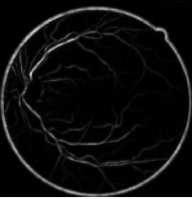 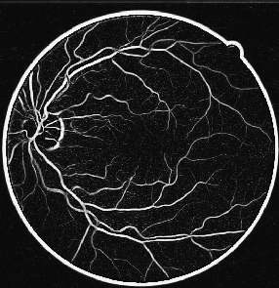 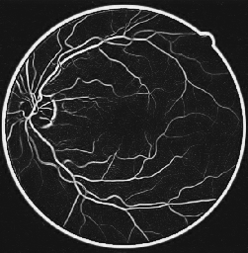

Clean by DCT dictionary Clean by Global dictionary Clean by Adaptive dictionary

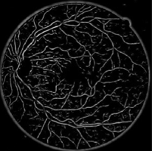 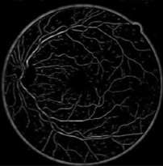

Clean by improved Global dictionary Clean by improved Adaptive dictionary

Fig.9. Denoising Result by different dictionary

1. **PSNR Statistics and Analysis**

We have tested these five methods denoising results’ PSNR. The results are described in the Fig.10. Compared to Fig.9 with Fig.10, Although DCT dictionary, Global dictionary and the Adaptive dictionary these 3 traditional methods has got a higher PSNR value, their ability for reconstructing the weak vessels’ linear structure is not really well. After we improved the traditional methods, the PSNR value relatively lower than before, but it is still acceptable to us and there are more weak vessels can reconstruct.

1. **CONCLUDE AND FUTURE WORK**

This work has presented a simple method for fundus images denoising, to some extent, surpassing to recently publish leading alternatives. The proposed method is based on local operations and make use of the traditional dictionary learned algorithm (K-SVD) and the sparse decomposition algorithm (OMP). The content of the dictionary is of prime importance for the denoising process --- we have shown that a dictionary trained from sub fundus image. Furthermore, add an directional filter for judge and weight the weak vessels’ linear structure in the sparse decomposition stage.

There are several directions that we are currently considering, such as optimizing the algorithms’ parameters, replacing the OMP and K-SVD by a better pursuit technique and dictionary training technique respectively. Beyond these, one direction we consider to be promising is to find a better method to detect the weak vessels’ linear structure. This work concentrated on some popular linear detection algorithms. We are studying ways to find and test their denoising results.

**REFERENCE**

1. B. JL Photo physical Processes in Recent Medical Laser Developments. Lasers Med Sci., 1986, 1: 47-66
2. Niall Patton, Tariq M. Aslam, Thomas MacGillivray, et al. Retinal image analysis: Concepts, applications and potential, Progress in Retinal and Eye Research, 2006, 25(1): 99-127
3. Mai S. Mabrouk, Nahed H. Solouma and Yasser M. Kadah. Survey of Retinal Image Segmentation and Registration[J]. Graph. Vis. Image Process Journal, 2006, 6(2): 1-11
4. M. Amin, H. Yan, High Speed Detection of Retinal Blood Vessels in Fundus Image Using Phase Congruency, Soft Computing – A Fusion of Foundations, Methodologies and Applications, 2011, 15(6): 1-14
5. M.M. Fraz, S.A. Barman, P.Remagnino, A. Basit, et al An Approach to Localize the Retinal Blood Vessels Using Bit Planes and Centerline Detection, Computer Methods and Programs in Biomedicine, 2011, 08,009
6. T.Mapayi, S Viriri, JR Tapamo, Comparative study of retinal vessel segmentation based on global thresholding techniques, Computational and Mathematical Methods in Medicine, 2015, 2015: 1-15
7. Frangi A F, Niessen W J, Vincken K L, et al. Multiscale vessel enhancement filtering[M]//Medical Image Computing and Computer-Assisted Interventation. Springer Berlin Heidelberg, 1998: 130-137.
8. Wright J, Ma Y, Mairal J, et al. Sparse representation for computer vision and pattern recognition[J]. Proceedings of the IEEE, 2010, 98(6): 1031-1044.
9. Aharon M, Elad M, Bruckstein A. K-SVD: An Algorithm for Designing Overcomplete Dictionaries for Sparse Representation[J]. Signal Processing, IEEE Transactions on, 2006, 54(11): 4311-4322.
10. Elad M, Aharon M. Image Denoising Via Sparse and Redundant Representations Over Learned D[J].Image Processing, IEEE Transactions on, 2006, 15(12) 3736-3745.
11. Elad M, Aharon M. Image denoising via learned dictionaries and sparse representation[C]//Computer Vision and Pattern Recognition, 2006 IEEE Computer Society Conference on. IEEE, 2006, 1: 895-900.
12. Donoho D L, Elad M, Temlyakov V N. Stable recovery of sparse overcomplete representations in the presence of noise[J]. Information Theory, IEEE Transactions on, 2006, 52(1): 6-18.
13. Jiang Z, Lin Z, Davis L S. Label consistent K-SVD: Learning a discriminative dictionary for recognition[J]. Pattern Analysis and Machine Intelligence, IEEE Transactions on, 2013, 35(11): 2651-2664.
14. Rubinstein R, Bruckstein A M, Elad M. Dictionaries for sparse representation modeling[J]. Proceedings of the IEEE, 2010, 98(6): 1045-1057.
15. Frangi A F, Niessen W J, Vincken K L, et al. Multiscale vessel enhancement filtering[M]//Medical Image Computing and Computer-Assisted Interventation. Springer Berlin Heidelberg, 1998: 130-137.
16. Gemmeke J F, Virtanen T, Hurmalainen A. Exemplar-based sparse representations for noise robust automatic speech recognition[J]. Audio, Speech, and Language Processing, IEEE Transactions on, 2011, 19(7): 2067-2080.
17. Elad M. Sparse and Redundant Representation Modeling-What Next?[J]. Signal Processing Letters, IEEE Transactions on, 2012, 19(12): 922-928.
18. Rubinstein R, Bruckstein A M, and Elad M. Dictionaries for sparse representation modeling[J]. Proceedings of the IEEE, 2010, 98(6):1045-1057.